6.1.1 Incremented Date
ALGORITHM
Step 1: Start the program.
Step 2: Input day (DD).
Step 3: Input month (MM).
Step 4: Input year (YYYY).
Step 5: Check if year ≤ 0.
If yes, print "Invalid Date" and go to Step 20.
Step 6: Check if month < 1 or month > 12.
If yes, print "Invalid Date" and go to Step 20.
Step 7: Determine if the year is a leap year using the condition:
If (year % 400 == 0) OR (year % 4 == 0 AND year % 100 ≠ 0),
then leap_year = True,
else leap_year = False.
Step 8: Set maximum days in the month:
If month is 1, 3, 5, 7, 8, 10, or 12 → max_days = 31.
Step 9: Else if month is 4, 6, 9, or 11 → max_days = 30.
Step 10: Else if month is 2:
If leap_year is True → max_days = 29.
Else → max_days = 28.
Step 11: Check if day < 1 or day > max_days.
If yes, print "Invalid Date" and go to Step 20.
Step 12: If day < max_days, then
new_day = day + 1
new_month = month
new_year = year
Step 13: Else if day == max_days and month ≠ 12, then
new_day = 1
new_month = month + 1
new_year = year
Step 14: Else if day == 31 and month == 12, then
new_day = 1
new_month = 1
new_year = year + 1
Step 15: Display the incremented date in the format
DD-MM-YYYY
Step 16: End the program.
PYTHON CODE
day = int(input())
month = int(input())
year = int(input())

def is_leap_year(year):
if (year % 400 == 0) or (year % 4 == 0 and year % 100 != 0):
return True
return False

if year <= 0:
print("Invalid Date")

elif month < 1 or month > 12:
print("Invalid Date")

else:

if month in [1, 3, 5, 7, 8, 10, 12]:
max_days = 31
elif month in [4, 6, 9, 11]:
max_days = 30
elif month == 2:
if is_leap_year(year):
max_days = 29
else:
max_days = 28

if day < 1 or day > max_days:
print("Invalid Date")
else:

day += 1

if day > max_days:
day = 1
month += 1

if month > 12:
month = 1
year += 1

print(f"{day:02d}-{month:02d}-{year}")
FLOWCHART
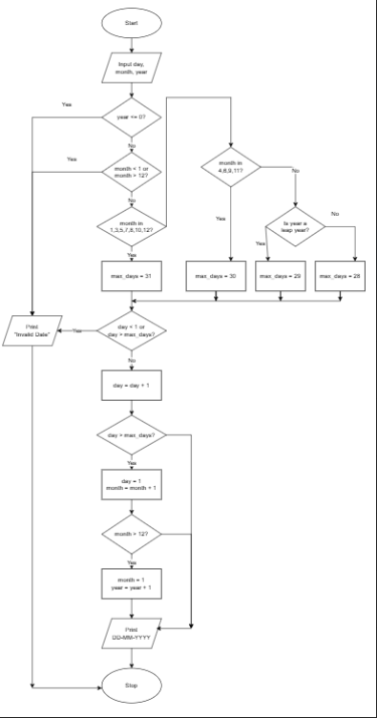
EXCECUTION
